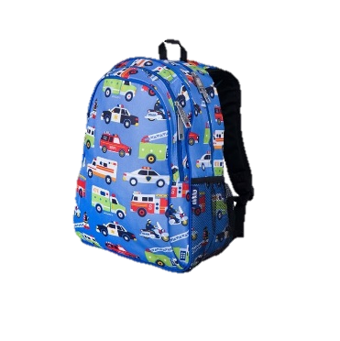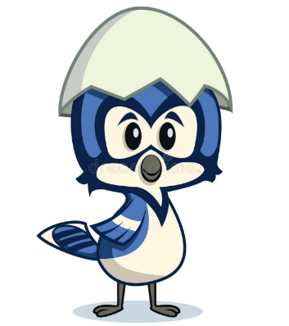 **Spring Lake Elementary**

VPK Supply List

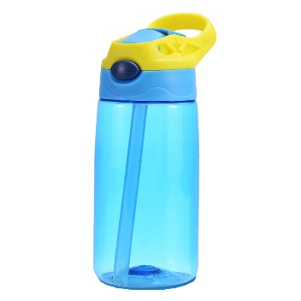 2021-22

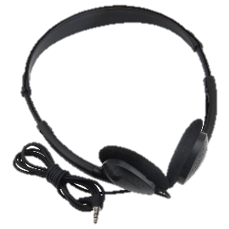 Personal Items

* Change of Clothes in a Ziploc Bag (shirt, shorts, socks, underwear)
* **Full-Size** Backpack (no wheels)
* Plastic Sleep Mat

(**NO larger** than 20 inch x 45 inch)

* Headphones
* Plastic Reusable Water Bottle
* **Small** Blanket & “Snuggle Buddy” (stuffed animal, etc.)

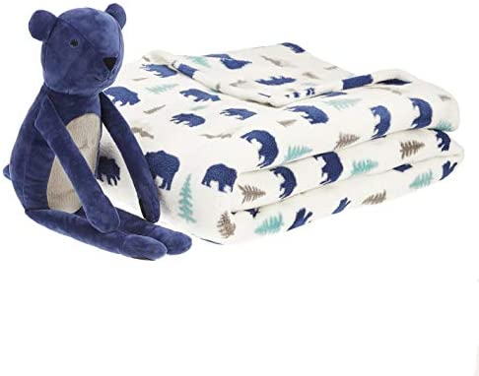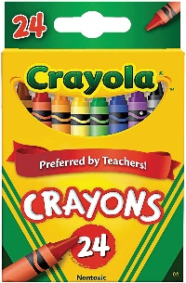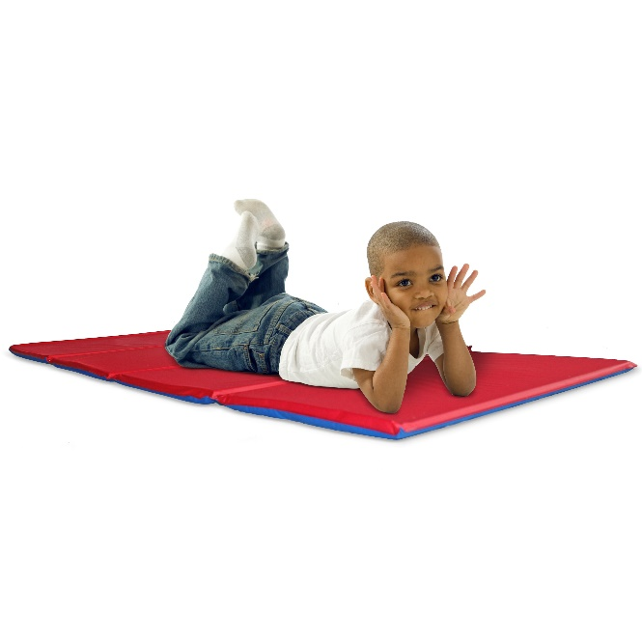

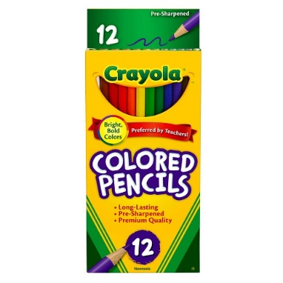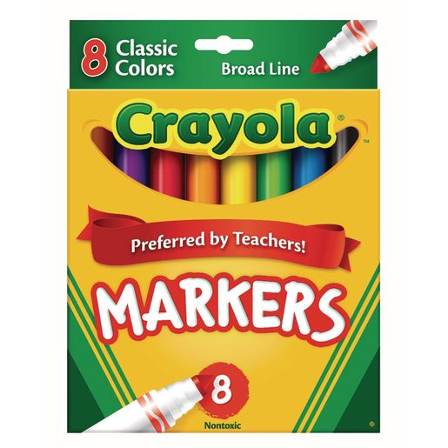 Supplies

* 1 Box of Crayons (24 count)
* 1 Box of Washable Markers (8 count)
* 1 Box of Colored Pencils (12 count)
* 4 Highlighters (different colors)
* 1 Watercolor Paint Set
* 4 Containers of PlayDoh

(2 each of 2 colors)

* 2 Plastic Folders with prongs & pockets (any colors)
* 3 Packages Wet Wipes

